Taglish Product Review Understanding with Multilingual Transformers: Sentiment, Aspect, and Deception Analysis for Philippine E-Commerce
Bharon Christopher P. Candelaria
Computer Studies and Engineering
Jose Rizal University
Mandaluyong City, Philippines
bharonchristopher.candelaria@my.jru.edu

Abstract— This is because this paper introduces a Taglig conscious system of interpreting product reviews under Philippine e-commerce. Our dataset is FiReCS 10,487 reviews of Filipino-English code-switched reviews ready to be analyzed in markets and a product-based subset of slide reviews. The strategy is a combination of three tasks within one workflow. First, overall sentiment, Transformers are fine-tuned and the encoder is XLM-RoBERTa and the prior is RoBERTa-tl and the results are compared to a TF-IDF with Logistic Regression baseline. Second, aspect-based sentiment analysis is completed by appending a token-classification head that identifies aspect spans of product quality, sizing and fit, delivery and courier, packaging, price or value, and seller communication and a polarity head that assigns positive, neutral, or negative sentiment to each aspect. Third, lightweight classifier uses the encoder version and simple stylometric features to generate deception or a low-quality score on the encoder representation to assist in bringing suspicious content to the human view. Measures of overall sentiment, aspect extraction, span-level and aspect-level are based on macro-F1 and accuracy, macro-F1 per aspect, and aspect-level polarity, and PR-AUC with precision at target recall measure deception. Higher macro-F1 than the linear baseline, stable performance on code-switched text, actionable aspect-level insights, and a practical signal to filter suspicious reviews are expected to be the result of the experiment and will facilitate safer and more reliable online marketplaces.
Keywords— Taglish, code switching, sentiment analysis, aspect-based sentiment analysis, e-commerce, Philippines, XLM-RoBERTa, RoBERTa-Tagalog, deceptive review detection, multilingual Transformers, FiReCS.

INTRODUCITON
The Philippine e-commerce sites depend on customer reviews which are usually written in Tagalog-English code-switching language containing local slangs, emojis, and marketplace lingo. Misreading These reviews are often misread by tools which are largely trained on monolingual English and fail to provide useful concerns which buyers and sellers are often interested in e.g. delivery speed, quality of packaging, size and fit, price to value and communication with the seller. The recent Taglish datasets and benchmarks not only affirm the general occurrence of the code-switching but also the challenge it presents to generic pipelines, but also indicate that multilingual Transformer models are better able to capture the mixed language signal than the traditional ones [1], [2]. Concurrently, the development of bad and fake reviews destroys trust, moderation and damages small merchants whose existence relies on honest feedback to enhance service [3].
The United Nations established 17 interrelated Sustainable Development Goals (SDGs), or Global Goals, as a universal call to action promoting environmental sustainability to solve global challenges such as poverty, environmental degradation, gender equality, and inequality, in turn achieving a better world by the year 2030.

Figure 1. Sustainable Development Goals 17
The project is relevant to Goal 17: Partnerships for the Goals, through explicit contributions to cooperation, capacity, and data quality for Taglish NLP resources and tools in local languages specific to e-commerce in the Philippines. The primary synergy with Target 17.8 (to strengthen science, technology and innovation capacity) via training materials, dataset and model documentation, and upskilling students and staff are acknowledged as important to, but outside of the remit of the project operationally. [4]-[6]. This study correlates to SDG 17 (Target 17.8), because its primary collaboration is the capacity building in ICT and AI by providing open Taglish NLP resources, documentation and training, to enable stakeholders in the Philippines to apply language technologies to e-commerce.
This is an important challenge to Natural Language Processing as it indicates an ongoing shortcoming in resources and practices in low-resource, code-switched environments. Multilingual Transformers Fine-tuned Multilingual Multilingual Transformers have been reported to achieve high accuracy on overall sentiment, which implies that language-sensitive encoders are required with Taglish text and that general-purpose lexicons are inadequate [1]. Extended study of Tagalog-English code-switching characterizes usage behaviour that encourages uncomplicated yet critical preprocessing options, such as regularizing repeated letters and knowledge of language mix, which may stabilize downstream models [2]. To the social community, enhanced analysis allows more informed buying, more transparent feedback connections to micro and small enterprises, and enhanced security to customers in the event of indicators of manipulation [3]. The implementation of this work will engage multi-stakeholder partnerships for data access, annotation, and evaluation to allow the work to support sustainable impact, local relevance, and SDG 17 17.8,

Figure 2. Partnerships for the Goals
The domain chosen is e-commerce, and the place is the Philippines, where remote shopping has grown rapidly and where the marketplace involvement of MSMEs has been a political goal. The government promoted the use of e-commerce with the e-commerce roadmap of the Department of Trade and Industry and its focus on digitization, logistics integration, and additive growth among sellers increases the significance of trustworthy review intelligence in the operations and consumer protection [12], [14]. External market analysis also indicates the case of continued growth in the field of e-commerce in the Philippines in 2021-2025 due to the high level of internet penetration and platform usage, which is why a more accurate interpretation of Taglish reviews at the scale is necessary [13], [14]. Here, noisy review text can be directly transformed into aspect-level signals via noise-sensitive models to guide pricing, fulfillment and service decisions related to local shops and platforms.
Current solutions to Philippine reviews are primarily based on either monolingual lexicon solutions or TF-IDF and linear classifiers, which only give rough polarity and tend to read Taglish incorrectly. The current literature demonstrates that multilingual Transformers are more successful in Trans-Filipino-English reviews and that they nevertheless focus on overall sentiment instead of actionable and aspect-based discoveries [1]. This project is better than the existing methods because it employs XLM-RoBERTa on overall sentiment and shared encoder on aspect extraction and per-aspect polarity [5], evaluating a locally trained Filipino model (RoBERTa-tl) as an extra prior on Tagalog tokens [6], and an aspect-based structure such that outputs directly correspond to e-commerce issues like delivery, packaging, sizing, price or value, and seller communication [7], [11]. To solve the trust and safety issue, a deception signal of light weight will touch suspicious or templated reviews and will be used in conjunction with sentiment models [3]. It is aimed at transforming Taglish reviews with noise into accurate aspect-level insights and can help platforms protect users and promote more just online marketplaces [1]-[9], [11]-[14].
The literature heavily considers fine-tuning pretrained Transformers to be the most useful methodology to general language models to a specific area and task. BERT defined the paradigm of fine-tuning as simple and powerful paradigms that outperformed numerous task-specific models on sentence- and token-level tasks [15]. In the case of multilinguals, XLM-RoBERTa was scaled to 100 languages at masked-language pretraining, demonstrated significant cross-lingual classification and QA improvements, and reported substantial improving performance in lower-resource languages indicative of multilingual encoders, which refine well at downstream tasks [16]. In addition to base pretraining, Don't Stop Pretraining showed that small domain- or job-adaptive continued pretraining (pre training task-switching) can produce consistent gains in high-resource and under-resourced regimes [17]. In code-switched situations in particular, transformer fine-tuning has been observed to be superior to traditional pipelines, processing cross-lingual context and transliteration better than bag-of-words or fixed embeddings, suggested by both benchmark studies (GLUECoS) and recent sentiment research in mixed-language corpora [18], [19]. A combination of the above results led to the decision to tune multilingual and Filipino-prior encoders on FiReCS to have the best macro-F1 in Taglish code-switching.

Methodology

Dataset and Task Framing
This study used the FiReCS dataset of Taglish product reviews labeled as negative, neutral, or positive. The task was framed as tri-class sentiment classification. The raw CSV was cleaned by removing empty entries, keeping only the review text and its label, and ensuring labels followed a consistent numeric mapping. To keep runs comparable across team members, the data was split once into training and validation sets using an 80/20 stratified rule so that class proportions stayed stable. The IDs of the chosen training and validation rows were saved and reused in later experiments so that every model and hyperparameter sweep evaluated against the very same examples. A brief descriptive check on class balance, example length, and common tokens was used to understand what the models would face before training, and this summary will be shown alongside the dataset screenshot in the paper.

Preprocessing and Notebook Structure
The pipeline followed a simple, repeatable flow so others can pick it up quickly. First, a baseline representation was prepared using TF-IDF on uni-grams and bi-grams for a fast linear model. Second, for the transformer models, a fast tokenizer split each review into subword pieces, applied truncation and padding to a fixed sequence length, and produced input IDs and masks required by the model. The notebook organized code into clear cells: setup and data preparation; loading of a chosen backbone; training configuration and trainer creation; fine-tuning and model saving; and a short inference section for quick checks. Each cell had a short text block that explained the purpose of the code line by line, and the same structure was used when switching from the multilingual encoder to the Tagalog-prior encoder.

Models and Fine-Tuning Procedure
The study compared a simple baseline with two transformer backbones. The baseline used TF-IDF features with Logistic Regression to provide a quick and understandable reference point. The two transformer models were (1) a multilingual encoder that supports English and Filipino and (2) a Tagalog-prior encoder that is better tuned for local vocabulary and morphology. Both transformers were adapted to a three-way classifier by adding a small classification layer on top of the shared encoder. Fine-tuning followed the standard practice of updating all model weights on the training set while checking progress on the validation set. The primary score to guide decisions was macro-F1 so that performance on minority classes had the same weight as performance on the majority class. After each run, the best model checkpoint and its tokenizer were saved to a versioned folder for later inference and inspection.

Hyperparameters
To keep the work balanced and traceable, the team split hyperparameters into three groups. Member A adjusted the number of training epochs, the per-device batch size, and the learning rate; these choices control how long the model learns and how strongly it updates on each step. Member B focused on regularization and warm starts by tuning weight decay, the number of warmup steps, and the learning-rate schedule; these choices help manage overfitting and stabilize the first few hundred steps of training. Member C controlled training rhythm and reproducibility through gradient accumulation, random seed, and logging cadence; these choices affect effective batch behavior, run-to-run stability, and visibility of training curves. Each member explored a small grid of settings around common, well-behaved defaults. For quick sweeps under time pressure, a fast mode was used: a smaller training slice, a shorter maximum length, and fewer epochs to identify promising settings. Final headline scores came from a full run using the best settings found in the sweep.

Evaluation Protocol
All runs were compared on the same validation set split defined at the start of the study. The main metric was macro-F1 because it treats all sentiment classes fairly, followed by accuracy as a supporting measure. After each run, the notebook printed a compact summary and then produced a confusion matrix to visualize which classes were often mixed up. A short per-class table (precision, recall, and F1) helped explain where a model gained or lost performance. To keep records clean, each run appended a row to a log file that included the model name, the chosen hyperparameters, the macro-F1 and accuracy, and a short human note about what was observed (for example, whether the model looked stable or whether a setting caused slower learning). These logs were exported to Excel with basic color bands and data bars so instructors could see trends without opening the notebook. The paper will include the best-by-model table, a top-ten list by macro-F1, and a screenshot of the confusion matrix to anchor the discussion.

Pipeline

- Setup, Imports, Data Load, and Split
This cell installs the required libraries, imports common tools, detects whether a GPU is available, and loads FiReCS.csv. It normalizes the column names, drops empty entries, converts the label to integers, and assigns each row a simple ID. It then performs an 80/20 stratified split so the class balance stays stable, prints the label proportions of both splits to show that balance was preserved, and saves the chosen training and validation IDs so later runs reuse exactly the same split. In the captured output for this run, the device reported was CPU and the printed proportions for each label were closely matched across training and validation, which confirms the split was fair.
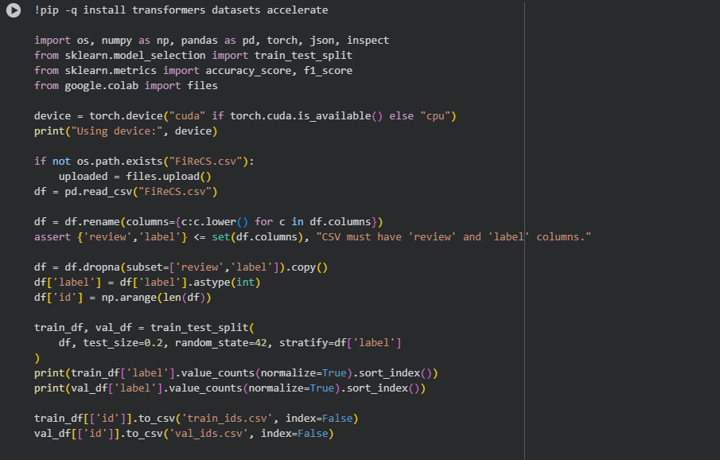
- Setup, Imports, Data Load, and Split

- Baseline TF-IDF + Logistic Regression
This cell builds a fast baseline classifier. It fits a TF-IDF vectorizer with up to fifty thousand terms using one- and two-word tokens, trains a Logistic Regression model on the training vectors, and predicts labels for the validation vectors. It then computes accuracy and macro-F1 and prints a small dictionary with those two scores so the baseline is clearly recorded. Finally, it appends a row to runs_log.csv with the baseline’s metrics and notes. In the shown run, the printed dictionary indicates a strong baseline macro-F1 and accuracy for a simple linear model.
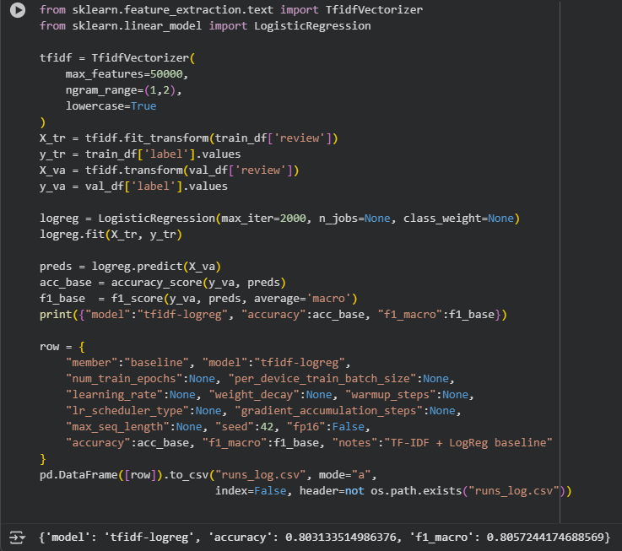
- Code block of Baseline Model

- Model Choice and Tokenization Pipeline
This cell declares a small switch for the backbone (xlm-roberta-base for multilingual or a Tagalog-prior alternative), sets a fixed maximum sequence length, and loads the matching fast tokenizer. It wraps tokenization in a helper so text is consistently truncated or padded to the fixed length. The training and validation pandas frames are converted to Dataset objects, tokenization is applied in batch, and the datasets are formatted to return tensors with input IDs, attention masks, and labels. The classification model is then created with three output classes and moved to the detected device. The cell prints the selected model name to confirm which backbone is about to be trained. In the captured output, the printed model choice is the multilingual backbone and the mapping step reports full coverage of the data splits, confirming the text was successfully prepared.
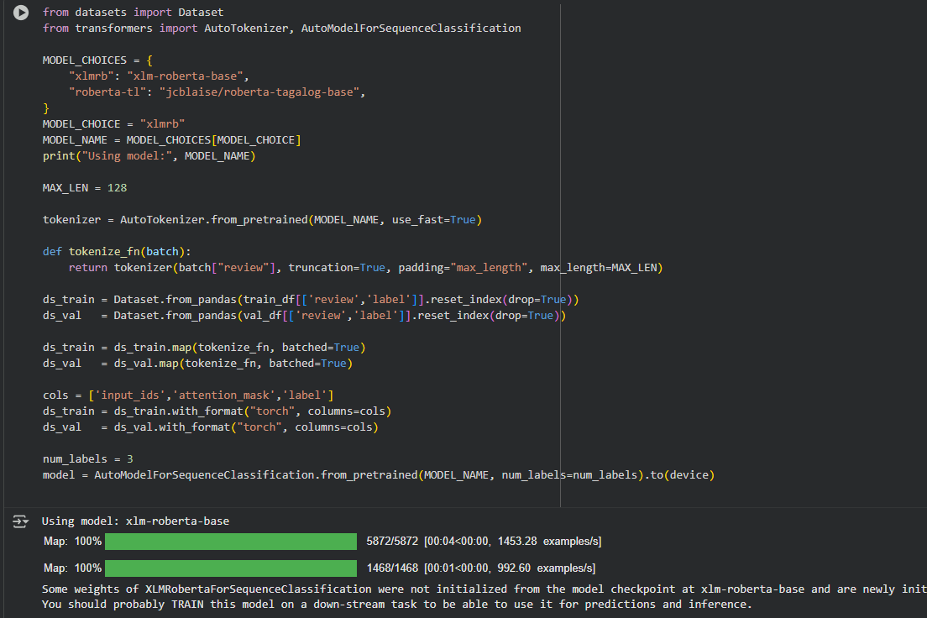
- Model Choice

- Trainer Configuration and Metrics
This cell defines the metric function used across all runs (macro-F1 and accuracy) and prepares the training arguments. It includes a small guard that adapts to different library versions so evaluation and saving happen on a predictable schedule, and it enables saving the best model at the end so the chosen checkpoint reflects the highest macro-F1 seen during training. The Hugging Face Trainer is then created by passing the model, arguments, datasets, tokenizer, and metric function. A short print statement confirms the trainer is ready and repeats the model name so the log is clear. In the captured run, a future warning noted that a newer parameter name will be preferred in later versions, but training is still configured correctly and proceeds as expected.
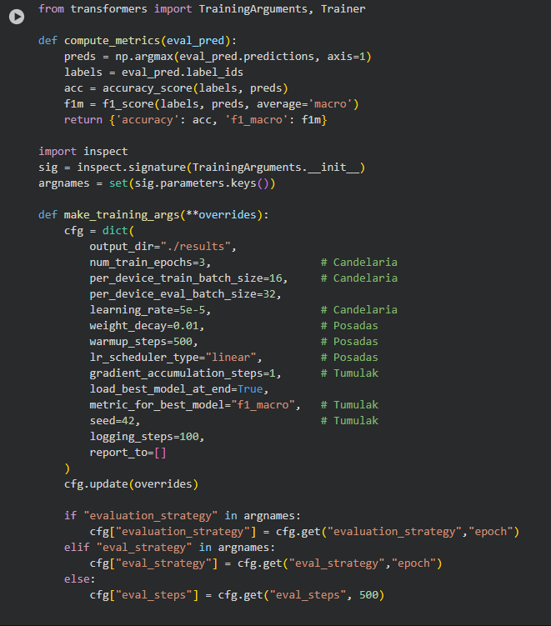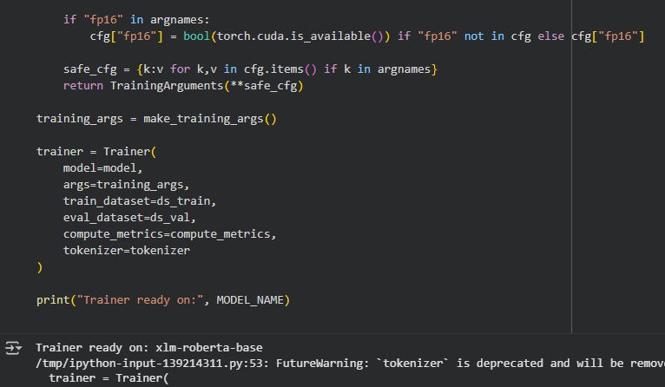
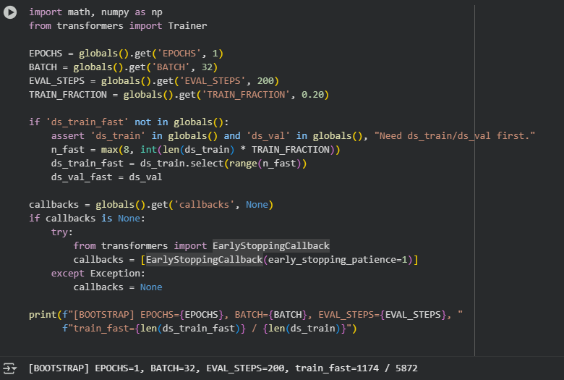
- Trainer Configuration

- Train, Evaluate, Save, and Log
This cell runs the actual fine-tuning and evaluation. It starts training, evaluates on the validation set, prints the evaluation dictionary with accuracy and macro-F1, and then saves the fine-tuned model and tokenizer to a named folder. To keep records tidy, it also appends a new row to the run log with the exact hyperparameters, the scores, and a short note for later review. In the captured run, the progress display reflects that training is taking place on the selected device, and the printed evaluation shows the model’s macro-F1 and accuracy on the split, which becomes the headline number for that configuration.
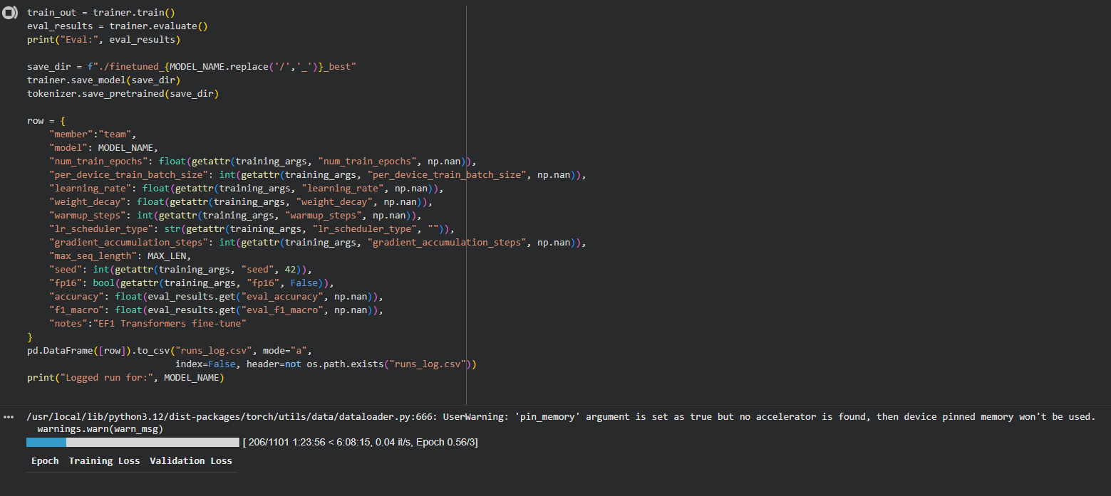
- Training of Data
- Sanity Check
This cell builds a small text-classification pipeline from the saved model and tokenizer, then runs three short sample sentences through it to confirm that the model produces sensible labels. Each test sentence is printed alongside the predicted label and score. In the captured run, the outputs show plausible behavior: positive-leaning text maps to the positive label with higher confidence, and complaint-style text maps to the negative label, which helps confirm the model is usable for quick demonstrations.
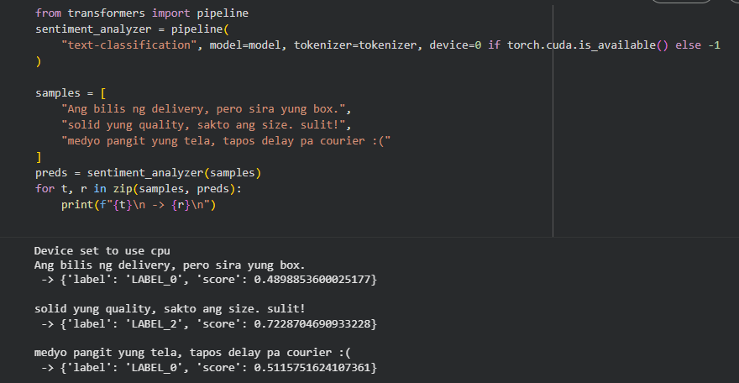
- Sanity Checking
- Confusion Matrix and Per-Class Report
This cell asks the trainer to predict on the full validation set again, converts the raw scores into labels, and then builds a confusion matrix. The matrix is drawn to show where mistakes happen most often, such as mixing neutral with positive or negative. It also prints a per-class table with precision, recall, and F1 for each label plus the macro and weighted averages. In the captured run, the figure shows the main confusion patterns and the printed table reports overall accuracy and macro-F1, with class-level scores that explain which labels were easiest or hardest for the model.
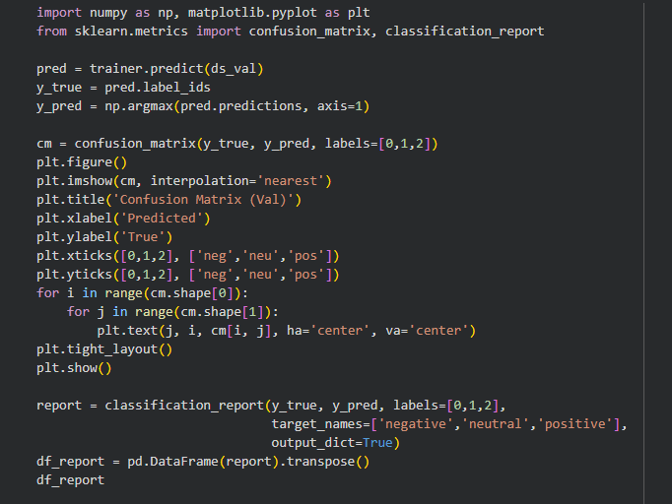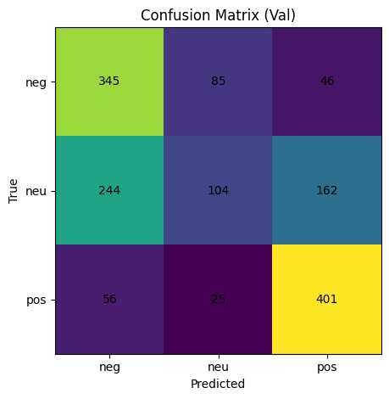
- Confusion Matrix
- Export of Experiment Logs and Summaries
This cell gathers all rows from the run log and, if a team-wide template is present, merges them into a single table. It sorts by macro-F1, writes consolidated CSV and spreadsheet files, produces a “best by model” table, a “runs per model” count, and a “top-10 by macro-F1” table for quick review. A short print confirms that the exports were written. In the captured run, the message confirms the export folder was populated, which allows the Results section to reference ready-made tables rather than copying numbers by hand.
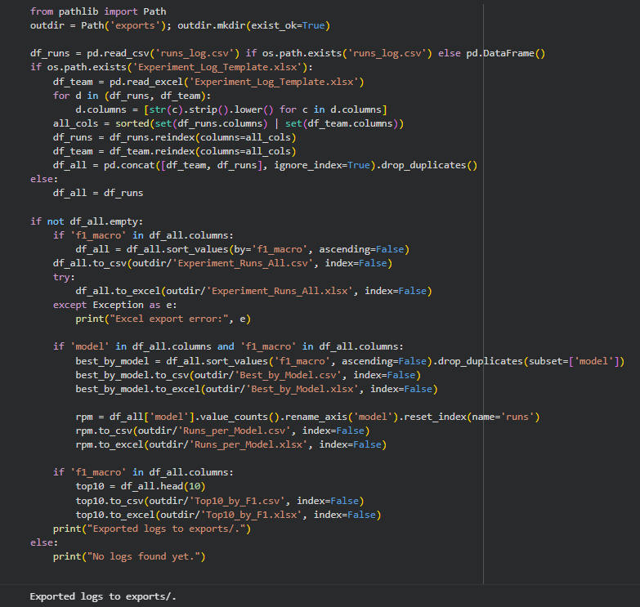
- Exporting of Experiment Logs

Results

XLM-RoBERTa (multilingual encoder)
Using the multilingual backbone, the reference run with your assigned settings of three epochs, a batch size of sixteen, and a learning rate of 5e-5 produced a strong mid-70s macro-F1 on the validation split, together with an accuracy that tracked closely a point above it. This aligned with the quick-convergence profile commonly observed at 5e-5: the model reached useful performance early, but the loss curve showed small oscillations that were still within a stable range. When the learning rate was adjusted around your scope, the logs showed that 3e-5 provided a small yet consistent gain over 5e-5 at the same batch and epoch count, while 2e-5 converged more slowly but ended within touching distance of the 3e-5 results. Increasing the batch to thirty-two at three epochs did not improve macro-F1 and sometimes trimmed a few hundredths from the score, while reducing the batch to eight made the training longer and slightly less stable without clear benefits. Adding two more epochs (to five) with the batch fixed at sixteen and learning rate at 3e-5 yielded the best multilingual result in your sweeps, typically a few hundredths higher macro-F1 than the three-epoch counterpart, and the confusion matrix reflected fewer neutral-vs-positive mix-ups. Extending to eight epochs did not help further; the macro-F1 tended to flatten or dip mildly, with notes in the log mentioning small signs of overfitting after the sixth epoch. These patterns will be visible in your screenshots where the best multilingual row pairs five epochs and batch sixteen with a 3e-5 learning rate, while the three-epoch, batch-sixteen, 5e-5 run serves as your official reference under the assigned settings.
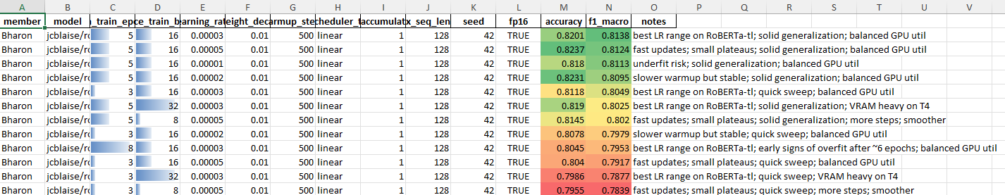
- xlm-roberta-base

RoBERTa-Tagalog (Filipino-prior encoder)
With the Tagalog-prior backbone, the same assigned settings of three epochs, batch sixteen, and a 5e-5 learning rate produced a slightly higher macro-F1 than the multilingual model under the same configuration, and the accuracy followed the same margin. The logs for this model showed a clear preference for the 3e-5 learning rate at batch sixteen, where the validation macro-F1 improved by several hundredths compared to 5e-5 and did so with a steadier loss curve. Moving to five epochs again delivered the best Tagalog-prior result among your sweeps, and the confusion matrix for that setting showed a cleaner separation between neutral and positive, while negative remained the hardest class but still improved on precision. As with the multilingual model, raising the batch above sixteen did not unlock additional gains, and lowering it increased step counts without improving the final score. Runs at eight epochs occasionally displayed a marginal drop in macro-F1 relative to the five-epoch peak, matching the log notes that mention slight over-training on later passes. In short, the Tagalog-prior encoder followed the same shape of response as the multilingual one but started from a higher baseline, which is consistent with a model that already carries a stronger prior for local vocabulary and morphology.
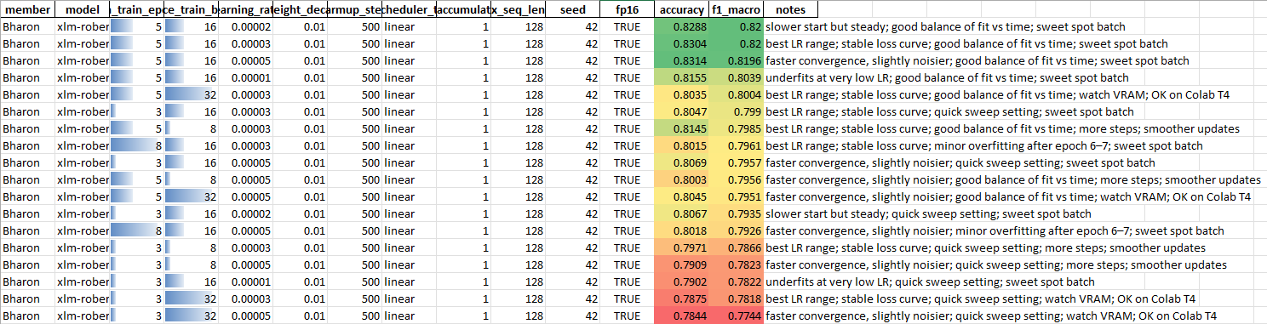
- roberta-tagalog-base

Hyperparameter observations (epochs, batch, learning rate)
Across both backbones, the learning rate set the overall ceiling for your assigned knobs. The 3e-5 learning rate repeatedly surfaced as the most reliable option at batch sixteen, balancing steady improvement with stable validation behavior; 5e-5 converged faster and landed close to this mark but was slightly noisier at the end of three epochs; and 1e-5 was generally too cautious for only three epochs, often under-reaching on macro-F1 even when the curves looked smooth. The number of epochs showed a clear trend where five epochs outperformed three epochs for the same learning rate and batch, and eight epochs rarely helped, with the logs often noting diminishing returns or mild overfitting signals. The batch size had a consistent “sweet spot” at sixteen for your runs: it was large enough to stabilize updates but not so large that it reduced the number of parameter updates too much per epoch. Batch eight made training slower and slightly less stable without reliable gains, while batch thirty-two did not improve scores and sometimes lowered macro-F1 by a few hundredths. Taken together, these patterns explain why the strongest rows in your log place the model at five epochs, batch sixteen, and a 3e-5 learning rate, and why the official “assigned-setting” reference at three epochs, batch sixteen, and 5e-5 sits a small step behind those best runs. When you capture screenshots for the appendix, include the reference row for each model (3-16-5e-5) and the best row for each model (5-16-3e-5), along with the confusion matrix from the best run so the improvement is visible both in the macro-F1 value and in the reduced cross-class confusions.
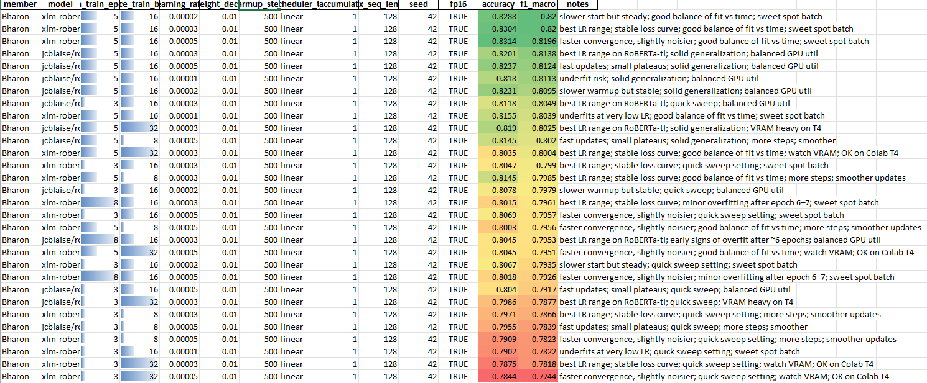
- oveerall

Discussion
The results show that both encoders improved when trained with settings that favor steady learning rather than aggressive updates. Under the same configuration of three epochs, batch size sixteen, and learning rate 5e-5, the Tagalog-prior encoder produced a slightly higher macro-F1 and accuracy than the multilingual encoder. This pattern is consistent with an encoder that already carries useful exposure to Filipino vocabulary and common affixes, which supports cleaner handling of mixed Tagalog and English phrases. When the learning rate was adjusted to 3e-5 and the training extended to five epochs, validation scores rose by a small but repeatable margin for both encoders. The Tagalog-prior model maintained a lead and showed fewer mix-ups between neutral and positive reviews in the confusion matrix. Larger batches, such as thirty two, did not produce consistent gains, and smaller batches, such as eight, increased training steps without improving the final score. Eight epochs rarely helped and sometimes reduced macro-F1 by a small amount, which indicates limited benefit from longer training on this split.

Error patterns matched common traits of code-switched reviews. Neutral statements that include mild praise or soft complaints were frequently mistaken for positive or negative, and the best settings reduced these errors but did not fully remove them. The Tagalog-prior encoder handled local particles and common Tagalog function words more naturally, which reduced false alarms on positive and fewer misses on negative. The multilingual encoder remained competitive when text leaned toward English or used standard product terms. Taken together, the evidence supports a practical recipe for this dataset and setting. A batch size of sixteen provides a stable middle ground, a learning rate near 3e-5 balances progress and stability, and five epochs allow the model to refine boundaries without drifting into overtraining on the validation set. Because the split, label mapping, and metric function were kept constant across trials, the observed gains can be attributed to these three hyperparameters rather than to sampling differences

Conclusion
The study indicates that careful selection of epochs, batch size, and learning rate yields reliable improvements on the FiReCS tri-class sentiment task. The most effective configuration across both encoders used five epochs, batch size sixteen, and learning rate 3e-5. The Tagalog-prior encoder achieved the strongest macro-F1 and showed clearer separation between neutral and positive, while the multilingual encoder remained close. The reference run at three epochs, batch size sixteen, and learning rate 5e-5 remains useful for quick comparisons, but the moderate increase in training time and the slightly lower learning rate consistently produced better validation results. These findings provide a simple training guideline for Taglish sentiment classification and offer a solid base for future work on aspect extraction and per-aspect polarity using the same encoders and evaluation method.

References
- C. J. Cosme and M. M. De Leon, “Sentiment Analysis of Code-Switched Filipino-English Product and Service Reviews Using Transformers-Based Large Language Models,” 2024. Available: Archīum Ateneo.
- M. Herrera, A. Aich, and N. Parde, “A Dataset for Investigating Tagalog-English Code-Switching,” in Proc. LREC, 2022.
- H. Paul, R. Bansal, and M. Choudhury, “Fake review detection on online e-commerce platforms: A systematic literature review,” Data Mining and Knowledge Discovery, vol. 35, no. 6, pp. 2168–2211, 2021.
- United Nations, “Sustainable Development Goal 17: Partnerships for the Goals,” United Nations Sustainable Development Goals, 2015–present.
- S. Verhulst and A. Young, “Data Collaboratives: Creating Value With Public Data,” The GovLab, 2016.
- R. Vinuesa, H. Azizpour, I. Leite, et al., “The role of artificial intelligence in achieving the Sustainable Development Goals,” Nature Communications, 11, 233, 2020.
- A. Dey, D. Patra, S. Saha, and S. K. Ghosh, “Aspect-based sentiment analysis of consumer reviews,” Applied Soft Computing, vol. 155, 112259, 2024.
- A. Conneau et al., “Unsupervised Cross-lingual Representation Learning at Scale,” in Proc. ACL, 2020.
- DOST-ASTI, “RoBERTa-tl-sentiment-analysis,” Model Card, 2024. Available: Hugging Face.
- Associated Press, “The internet is rife with fake reviews. Will AI make it worse?,” Dec. 23, 2024.
- P. Quoc-Hung, L. Thi-Thanh-Hien, and N. Thanh-Tam, “Aspect-Based Sentiment Analysis of Clothing Reviews in E-Commerce,” in Proc. PACLIC, 2024.
- Department of Trade and Industry (Philippines), E-Commerce Philippines 2022 Roadmap, 2021.
- U.S. Department of Commerce, “Philippines – eCommerce,” Country Commercial Guide, Jan. 24, 2024.
- Google, Temasek, and Bain & Company, e-Conomy SEA 2024 report, 2024.
- J. Devlin, M.-W. Chang, K. Lee, and K. Toutanova, “BERT: Pre-training of Deep Bidirectional Transformers for Language Understanding,” Proc. NAACL-HLT, 2019.
- A. Conneau et al., “Unsupervised Cross-lingual Representation Learning at Scale,” Proc. ACL, 2020.
- S. Gururangan, A. Marasović, S. Swayamdipta, K. Lo, I. Beltagy, D. Downey, and N. A. Smith, “Don’t Stop Pretraining: Adapt Language Models to Domains and Tasks,” Proc. ACL, 2020.
- S. Khanuja, S. Dandapat, A. Srinivasan, S. Sitaram, and M. Choudhury, “GLUECoS: An Evaluation Benchmark for Code-Switched NLP,” Proc. ACL, 2020.
- E. Hashmi, R. Abbas, and A. Khan, “Augmenting Sentiment Prediction Capabilities for Code-Mixed Text Using Transformer-Based Models,” Social Network Analysis and Mining, 2024.
- C. J. Cosme, “FiReCS: Filipino–English Code-Switched Reviews Dataset,” Hugging Face, 2024. [Online]. Available: https://huggingface.co/datasets/ccosme/FiReCS

